- D1 : Draw a rocket using fundamental knowledge of OpenGl and some basic built in functions

D2: Draw a home using fundamental knowledge of Opengl and some basic built in functions

- D1 : Drawing a robot using different OpenGL functions

D2 : Drawing Star using different OpenGL Function .

- Implementation of DDA line drawing algorithm

- Implementation of Bresenham’s Line Drawing algorithm

- Implementation of Mid-Point Circle Drawing algorithm.
Note : Implement it and draw half moon using it

- Drawing Different Object Using Circle

- 2D Implementation (Translation)

- 2D Implementation (Scaling)
Note : Modify the code of Translation for making object smaller to bigger or bigger to small

- Drawing different objects using different primitives, circle and 2D Transformation
Demo :

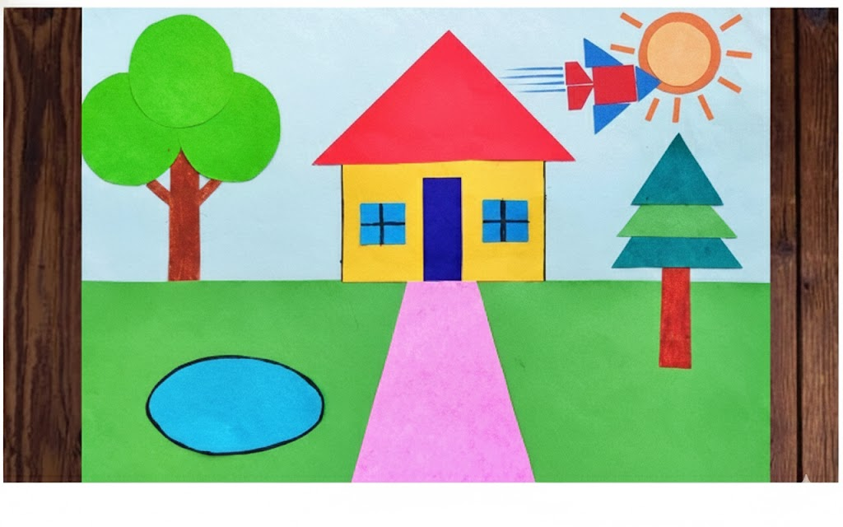
Or,
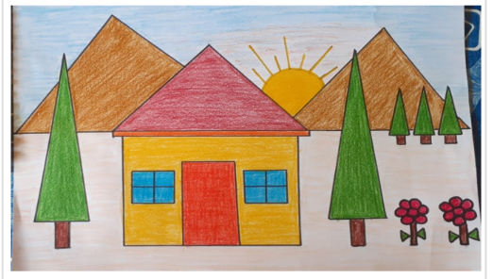
Or,
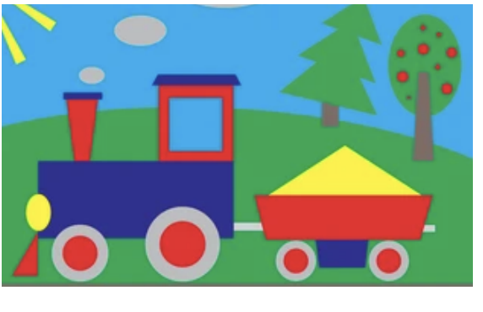

- 3D Implementation : Make objects using the provided code

https://docs.google.com/document/d/1fKvFDJNjBvCGbHZ3lymdFM_v41ydW5sM/edit?usp=drive_link&ouid=111580056622036537037&rtpof=true&sd=true

